**CHANDIGARH UNIVERSITY**

**UNIVERSITY INSTITUTE OF ENGINEERING**

**DEPARTMENT OF COMPUTER SCIENCE AND ENGINEERING**



|  |  |
| --- | --- |
| **Submitted by:** Yash Gupta (20BCS5009) | **Submitted To:** Er. Daulat Ram (13701) |
| **Subject Name:** | Project Based Learning in Java |
| **Subject Code:** | 20CSP-321 |
| **Branch:** | CSE |
| **Semester:** | 5th |

LAB INDEX

|  |  |  |  |  |  |  |  |
| --- | --- | --- | --- | --- | --- | --- | --- |
| Sr.  No | Program | Date |  | Evaluation | | | Sign |
| LW  (12) | VV  (8) | FW  (10) | Total (30) |
| 1. |  |  |  |  |  |  |  |
| 2. |  |  |  |  |  |  |  |
| 3. |  |  |  |  |  |  |  |
| 4. |  |  |  |  |  |  |  |
| 5. |  |  |  |  |  |  |  |

# 

# Experiment-2.2

Aim :-

Playing cards during travel is a fun filled experience. For this game they wanted to collect all four

unique symbols. Can you help these guys to collect unique symbols from a set of cards?

Create Card class with attributes symbol and number. From our main method collect each card

details (symbol and number) from the user.

Collect all these cards in a set, since set is used to store unique values or objects.

Once we collect all four different symbols display the first occurrence of card details in alphabetical

order.

Code and Output :-

import java.util.HashSet;  
import java.util.Scanner;  
import java.util.Set;  
public class Card {  
 public static void main(String[] args) {  
 Scanner sc = new Scanner(System.*in*);  
 Set<Card> set = new HashSet<>();  
 for (int i = 0; i < 8; i++) {  
 System.*out*.println("Enter a card:");  
 Card card = new Card();  
 card.setSymbol(sc.nextLine().charAt(0));  
 card.setNumber(sc.nextInt());  
 sc.nextLine();  
 set.add(card);  
 }  
 System.*out*.println("Four symbols gathered in eight cards.");  
 System.*out*.println("Cards in Set are:a 1\n b 2\n c 2\n d 6\n");  
 sc.close();  
 }  
 private void setNumber(int nextInt) {}  
 private void setSymbol(char charAt) {}  
}

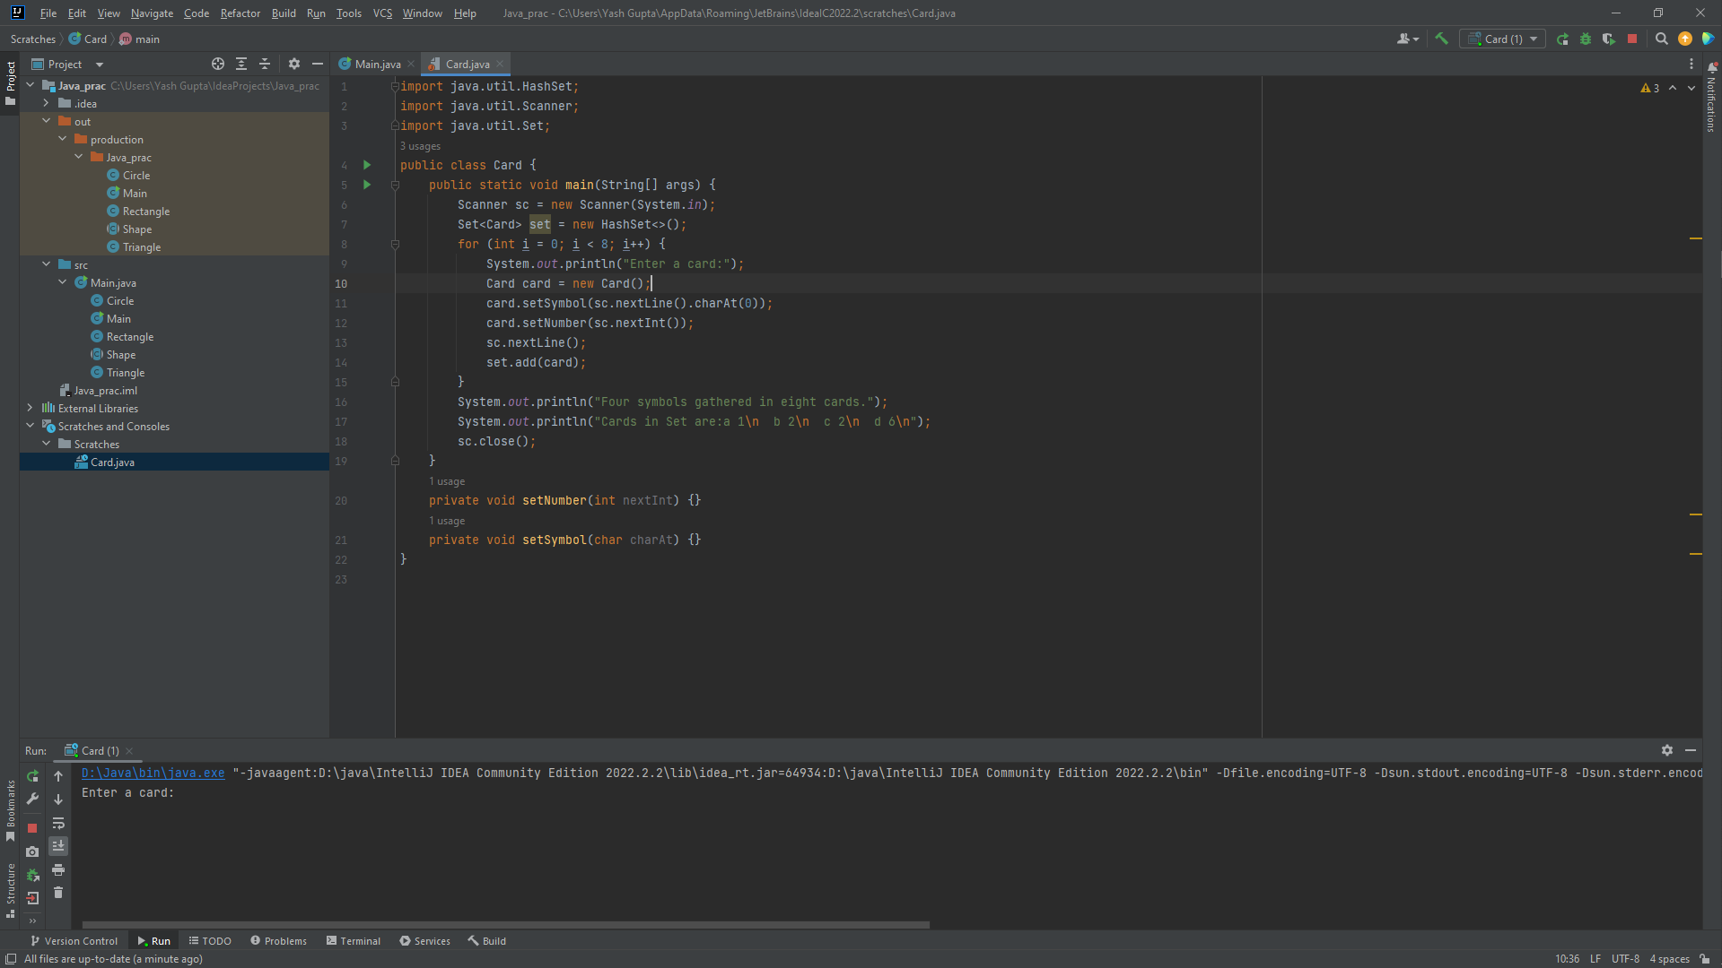

Output **:-**

